1. Check service information and determine the specified procedures to follow to replace
Evaluation (Enter number from 4, 3, 2, 1) :_________

Meets ASE Task: A7 – B-10 – P-2
Time on Task:_____________
Make/Model/Year:____________________________________
VIN:_________________________________
Date:_____________
Name:_____________________________________
Evaporator/ Heater Core Replacement
the evaporator. (List the procedures)
______________________________________________________________________________
______________________________________________________________________________
______________________________________________________________________________
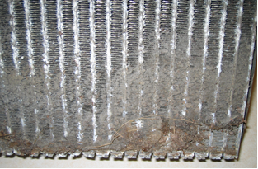
2. Check service information and determine the amount of oil needed to add to the system
when replacing the component. Oil amount = __________ oz/ ml.

