1. Check service information for the exact procedures to follow when replacing the
Evaluation (Enter number from 4, 3, 2, 1) :_________

Meets ASE Task: A7 – B-8 – P-1
Time on Task:_____________
Make/Model/Year:____________________________________
VIN:_________________________________
Date:_____________
Name:_____________________________________
Replace Expansion Valve/ Orifice Tube
expansion valve or orifice tube.
______________________________________________________________________________
______________________________________________________________________________
______________________________________________________________________________
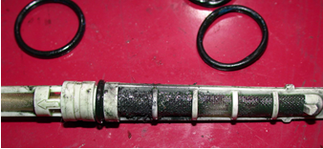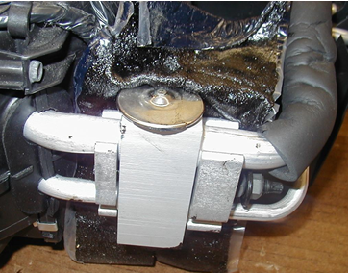

2. List the tools needed to perform the removal and installation of the expansion valve or
orifice tube.
a. _______________ d. _______________ g. _______________
b. _______________ e. _______________ h. _______________
c. _______________ f. _______________ i. _______________

