1. Using service information, determine the internal combustion engine service precautions:
Evaluation (Enter number from 4, 3, 2, 1) :_________

Meets ASE Task: A1 – A-8 – P-2
Time on Task:_____________
Make/Model/Year:____________________________________
VIN:_________________________________
Date:_____________
Name:_____________________________________
Hybrid Vehicle ICE Service Precautions
______________________________________________________________________________
______________________________________________________________________________

2. Place a check mark (√) next to each item that was included or found in the service information?
____ Be sure the ignition is off.
____ Be certain that the “ready” light is out.
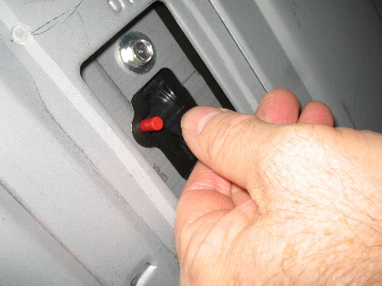
____ Use caution around hot surfaces.
____ Disable the high-voltage (HV) electrical system.
____ Disconnect a fuse or relay.
____ Remove a service plug.
____ Disconnect the 12-volt auxiliary battery.
____ Other (describe) _______________________________________________

3. Does the vehicle manufacturer specify that high-voltage linesman’s gloves be used?
_____ Yes _____ No If yes, when? _______________________________________________
______________________________________________________________________________
