1. Full hybrid example = ____________________________________________________________
Evaluation (Enter number from 4, 3, 2, 1) :_________

Meets ASE Task: Not specified by ASE
Time on Task:_____________
Make/Model/Year:____________________________________
VIN:_________________________________
Date:_____________
Name:_____________________________________
Types of Hybrid and Electric Vehicles
2. Medium hybrid example = ________________________________________________________
3. Mild hybrid example = ___________________________________________________________
3. Micro hybrid example = __________________________________________________________
4. Plug-in hybrid example = _________________________________________________________
5. Electric Vehicle example = ________________________________________________________
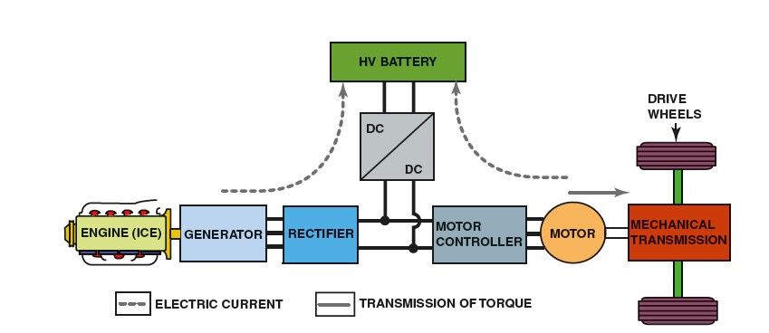
6. What is the system voltage used in full hybrid vehicles? ________________________________
7. What is the system voltage used in medium hybrid vehicles? ____________________________
8. What is the system voltage used in mild hybrid vehicles? _______________________________
9. What is the system voltage used in micro hybrid vehicles? ______________________________
10. What is the system voltage used in plug-in hybrid vehicles? _____________________________
11. What is the system voltage used in the electric vehicles? _______________________________

