1. Check service information for the location of the high voltage disconnect (service plug). Describe the location:
Evaluation (Enter number from 4, 3, 2, 1) :_________

Meets ASE Task: Foundational Task #14
Time on Task:_____________
Make/Model/Year:____________________________________
VIN:_________________________________
Date:_____________
Name:_____________________________________
Hybrid/ Electric Vehicle HV Circuit Disconnect
______________________________________________________________________________
______________________________________________________________________________
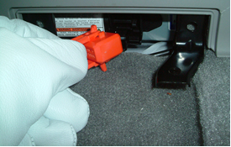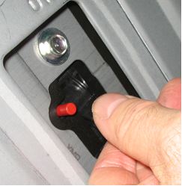
2. Check service information for the procedure to remove the high voltage disconnect (service plug). Describe the procedure:
______________________________________________________________________________
______________________________________________________________________________
______________________________________________________________________________
3. Check service information and list the safety precautions specified when de-powering the high- voltage circuits.
______________________________________________________________________________
______________________________________________________________________________
______________________________________________________________________________

