1. Review the service information to determine the location to test for loss of high voltage isolation. (describe):
Evaluation (Enter number from 4, 3, 2, 1) :_________

Meets ASE Task: L3 – E-3
Time on Task:_____________
Make/Model/Year:____________________________________
VIN:_________________________________
Date:_____________
Name:_____________________________________
Meg-Ohm Meter Usage
______________________________________________________________________________
______________________________________________________________________________

2. Follow the tool manufacturer instructions to setup the meg-ohm meter.
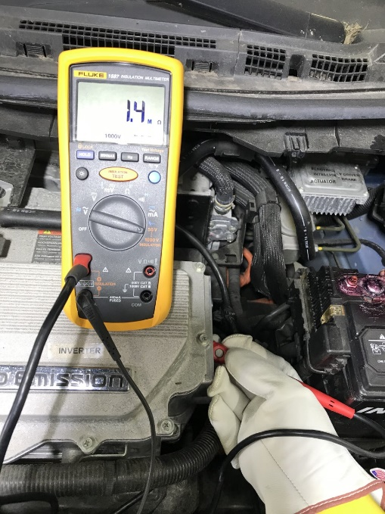
3. Using the service information as a guide, test the high voltage system for a loss of isolation.
Results: _________________________________

4. Based on the results, what actions are needed? (describe):
______________________________________________________________________________
______________________________________________________________________________

