1. Using the procedures found in the service information, isolate the electric motor(s) in the transmission from the wiring harness. (describe):
Evaluation (Enter number from 4, 3, 2, 1) :_________

Meets ASE Task: L3 – E-3
Time on Task:_____________
Make/Model/Year:____________________________________
VIN:_________________________________
Date:_____________
Name:_____________________________________
Milliohm Meter Usage
______________________________________________________________________________
______________________________________________________________________________

2. Plug in, warm, and adjust milliohm meter according to the manufacturer’s instructions.

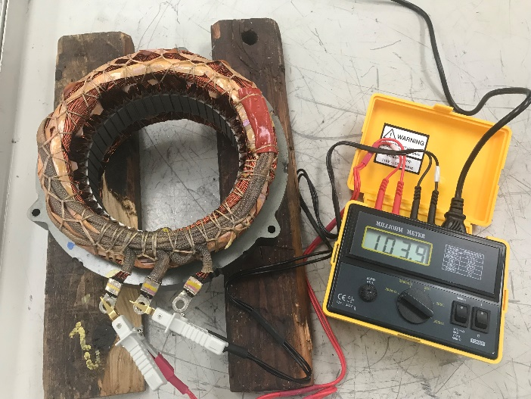
3. Measure the resistance between:
U-V: __________________________________
U-W: _________________________________
V- W: _________________________________
4. Based on the results, what actions are needed? (describe):
______________________________________________________________________________
______________________________________________________________________________

