1. Check service information for the recommended coolant testing, recover, flushing, and refilling procedures.
Evaluation (Enter number from 4, 3, 2, 1) :_________

Meets ASE Task: A1 – D-6 – P-1
Time on Task:_____________
Make/Model/Year:____________________________________
VIN:_________________________________
Date:_____________
Name:_____________________________________
HEV Test and Replace Coolant
______________________________________________________________________________
______________________________________________________________________________

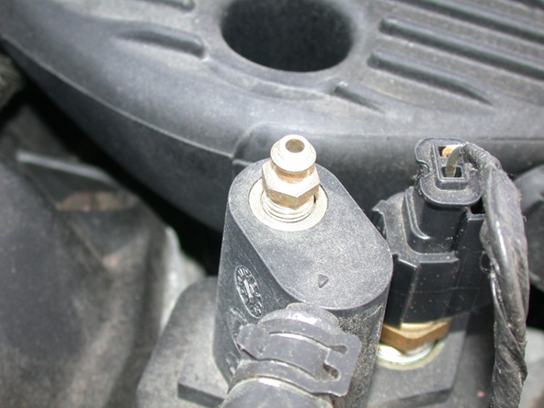

2. What is the recommended coolant? ________________________________________________

3. Are the cooling systems equipped with bleeder valves to help with bleeding trapped air from the cooling system when it is refilled?
______ No ______ Yes (describe location) ____________________________________
______________________________________________________________________________

