1. Check service information for the recommended procedures to follow to determine the piston-to-bore clearance. Describe the specified procedures.
Evaluation (Enter number from 4, 3, 2, 1) :_________

Meets ASE Task: A1 – C-12 – P-2
Time on Task:_____________
Make/Model/Year:____________________________________
VIN:_________________________________
Date:_____________
Name:_____________________________________
Bore to Piston Clearance
______________________________________________________________________________
______________________________________________________________________________
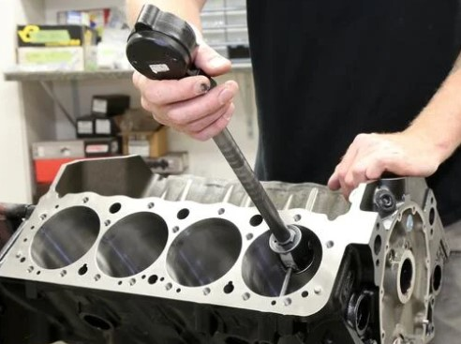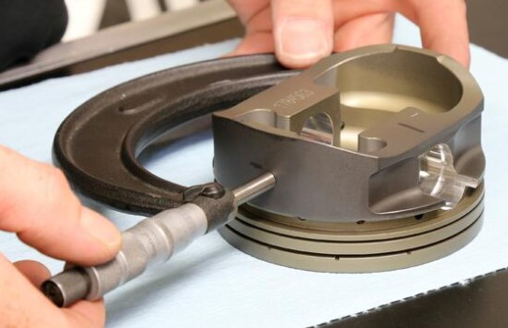

2. What is the specified piston-to-bore clearance? _______________________________________
3. Measure the piston-to-bore clearance on all cylinders:
Cylinder #1 ____________ OK _______ NOT OK _______
Cylinder #2 ____________ OK _______ NOT OK _______
Cylinder #3 ____________ OK _______ NOT OK _______
Cylinder #4 ____________ OK _______ NOT OK _______
Cylinder #5 ____________ OK _______ NOT OK _______
Cylinder #6 ____________ OK _______ NOT OK _______
Cylinder #7 ____________ OK _______ NOT OK _______
Cylinder #8 ____________ OK _______ NOT OK _______

