1. Check service information for the specified procedures to follow when assembling the engine block. Describe specified procedures.
Evaluation (Enter number from 4, 3, 2, 1) :_________

Meets ASE Task: A1 – C-15 – P-1
Time on Task:_____________
Make/Model/Year:____________________________________
VIN:_________________________________
Date:_____________
Name:_____________________________________
Assemble Engine Block
______________________________________________________________________________
______________________________________________________________________________
______________________________________________________________________________

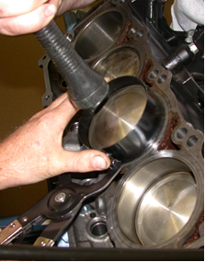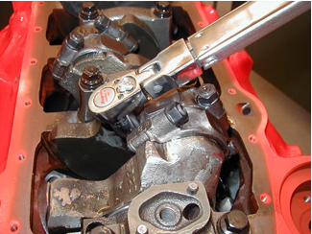

2. List the tools specified to be needed to assemble the engine block.
______________________________________________________________________________
______________________________________________________________________________
______________________________________________________________________________

