1. Check service information for the exact procedure and tools needed to remove and install the crankshaft vibration damper. Describe the procedures and list the tools needed.
Evaluation (Enter number from 4, 3, 2, 1) :_________

Meets ASE Task: A1 – C-2 – P-1
Time on Task:_____________
Make/Model/Year:____________________________________
VIN:_________________________________
Date:_____________
Name:_____________________________________
Inspect Crankshaft Vibration Damper
______________________________________________________________________________
______________________________________________________________________________
______________________________________________________________________________
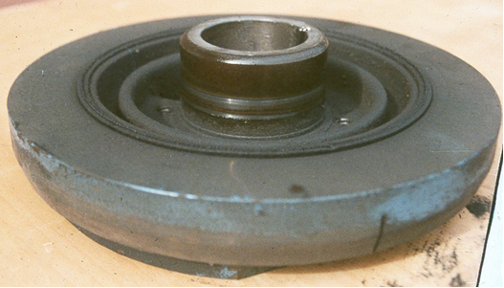
2. Check service information and determine what to look for during the inspection of the crankshaft vibration damper (describe procedures).
______________________________________________________________________________
______________________________________________________________________________
3. Based on the inspection, what actions need to be taken?
______________________________________________________________________________
______________________________________________________________________________

