1. Check service information for the specified measurements and inspection procedures. State recommended procedures. _______________________________________________________
Evaluation (Enter number from 4, 3, 2, 1) :_________

Meets ASE Task: A1 – C-11 – P-2
Time on Task:_____________
Make/Model/Year:____________________________________
VIN:_________________________________
Date:_____________
Name:_____________________________________
Piston Inspection and Measurement
______________________________________________________________________________

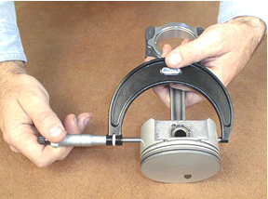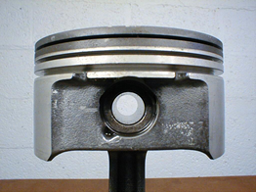

2. What is the specified piston skirt size? Measure and record the piston skirt diameter.
Piston cylinder #1 = __________ Piston cylinder #5 = __________
Piston cylinder #2 = __________ Piston cylinder #6 = __________
Piston cylinder #3 = __________ Piston cylinder #7 = __________
Piston cylinder #4 = __________ Piston cylinder #8 = __________

3. Based on the measurement and the inspection, what is the necessary action?
______________________________________________________________________________
______________________________________________________________________________

