1. Check service information for the exact procedures and specifications when checking camshaft bearings.
Evaluation (Enter number from 4, 3, 2, 1) :_________

Meets ASE Task: A1 – C-7 – P-2
Time on Task:_____________
Make/Model/Year:____________________________________
VIN:_________________________________
Date:_____________
Name:_____________________________________
Camshaft Bearing Inspection
a. Recommended procedures: ____________________________________________________
_____________________________________________________________________________
b. Specifications: ______________________________________________________________
_____________________________________________________________________________

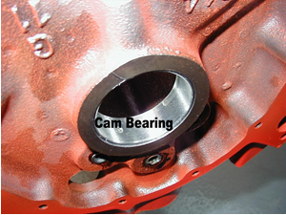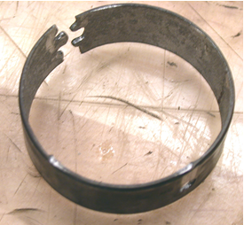

2. Based on the inspection and measurements, what is the necessary action?
______________________________________________________________________________
______________________________________________________________________________
______________________________________________________________________________

