1. Check service information for the specified procedures and measurements when inspecting a camshaft bearing surface. Describe specified procedures and specifications.
Evaluation (Enter number from 4, 3, 2, 1) :_________

Meets ASE Task: A1 – B-14 – P-3
Time on Task:_____________
Make/Model/Year:____________________________________
VIN:_________________________________
Date:_____________
Name:_____________________________________
Camshaft Bearing Surface Inspection
a. Procedures: _________________________________________________________________
______________________________________________________________________________
b. Camshaft bearing surface specifications: __________________________________________
______________________________________________________________________________

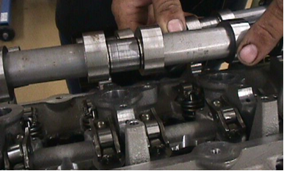

2. Based on the inspection and measurements, what is the necessary action?
_____________________________________________________________________________
_____________________________________________________________________________
_____________________________________________________________________________

