1. Check service information for the specified inspection procedures and specifications.
Evaluation (Enter number from 4, 3, 2, 1) :_________

Meets ASE Task: A1 – B-13 – P-3
Time on Task:_____________
Make/Model/Year:____________________________________
VIN:_________________________________
Date:_____________
Name:_____________________________________
Camshaft Inspection
a. List the inspection procedures: _______________________________________________
_____________________________________________________________________
b. List camshaft specifications: _________________________________________________
_____________________________________________________________________

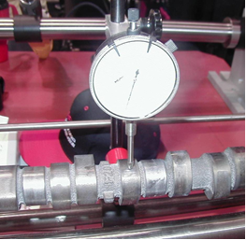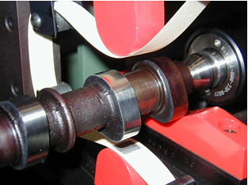
2. Measure the camshaft and compare with factory specifications.
________ OK ________ NOT OK (describe the fault) __________________________
__________________________________________________________________________

3. Based on the inspection and measurement of the camshaft, what is the necessary action?
___________________________________________________________________________
___________________________________________________________________________
___________________________________________________________________________

