1. Check service information for the recommended procedures to inspect and replace the water pump (describe recommended procedures). _________________________________________
Evaluation (Enter number from 4, 3, 2, 1) :_________

Meets ASE Task: A1 – D-8 – P-1
Time on Task:_____________
Make/Model/Year:____________________________________
VIN:_________________________________
Date:_____________
Name:_____________________________________
Replace Water Pump
______________________________________________________________________________
______________________________________________________________________________
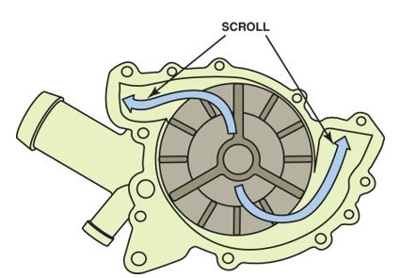

2. What are the torque specifications for the water pump fasteners? ________________________
______________________________________________________________________________
______________________________________________________________________________
______________________________________________________________________________

