1. Walk through the shop(s) area of the school or a local shop or dealership and check for the following items:
Evaluation (Enter number from 4, 3, 2, 1) :_________

Meets ASE Task: Not specified by ASE
Time on Task:_____________
Make/Model/Year:____________________________________
VIN:_________________________________
Date:_____________
Name:_____________________________________
Shop Safety Checklist
a. Shields on bench or pedestal grinders Yes______ No______ NA ______
b. Exhaust hoses in good repair Yes______ No______ NA ______
c. Fire extinguisher installed and charged Yes______ No______ NA ______
d. First aid kit visible and fully stocked Yes______ No______ NA ______
e. Fire blanket visible and useable Yes______ No______ NA ______
f. Eye wash station visible and usable Yes______ No______ NA ______
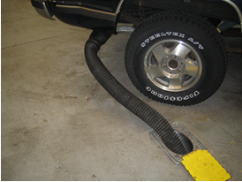
2. List anything that should be included in a safe shop that was not present.
______________________________________________________________________________
______________________________________________________________________________

3. What items of personal protective equipment were being worn by service technicians?
a. Safety glasses/face shield Yes______ No______ NA ______
b. Protective gloves Yes______ No______ NA ______
c. Hearing protection Yes______ No______ NA ______
d. Bump cap Yes______ No______ NA ______

