Hybrid Vehicle Electric Power Steering
Meets ASE Task: (A4-B-19) Identify hybrid vehicle power steering system electrical circuits, service and safety precautions. (P-2)

Name _______________________________ Date ___________ Time on Task __________

Make/Model/Year _________________ VIN ________________ Evaluation: 4 3 2 1

_____ 1. Check service information for the specified procedures to follow when servicing the
electric power steering on a hybrid electric vehicle (HEV). Describe the
recommended precautions.

__________________________________________________________________

__________________________________________________________________

_____ 2. What color is the protective conduit around the wiring to the electric power steering?

____ Black (usually 12 volts)

____ Blue (usually 42 volts)

____ Yellow (usually 42 volts)

____ Orange (usually 144+ volts)

_____ 3. Check service information for the specified tools and safety equipment specified when
servicing the electric power steering system on a hybrid electric vehicle. Check all
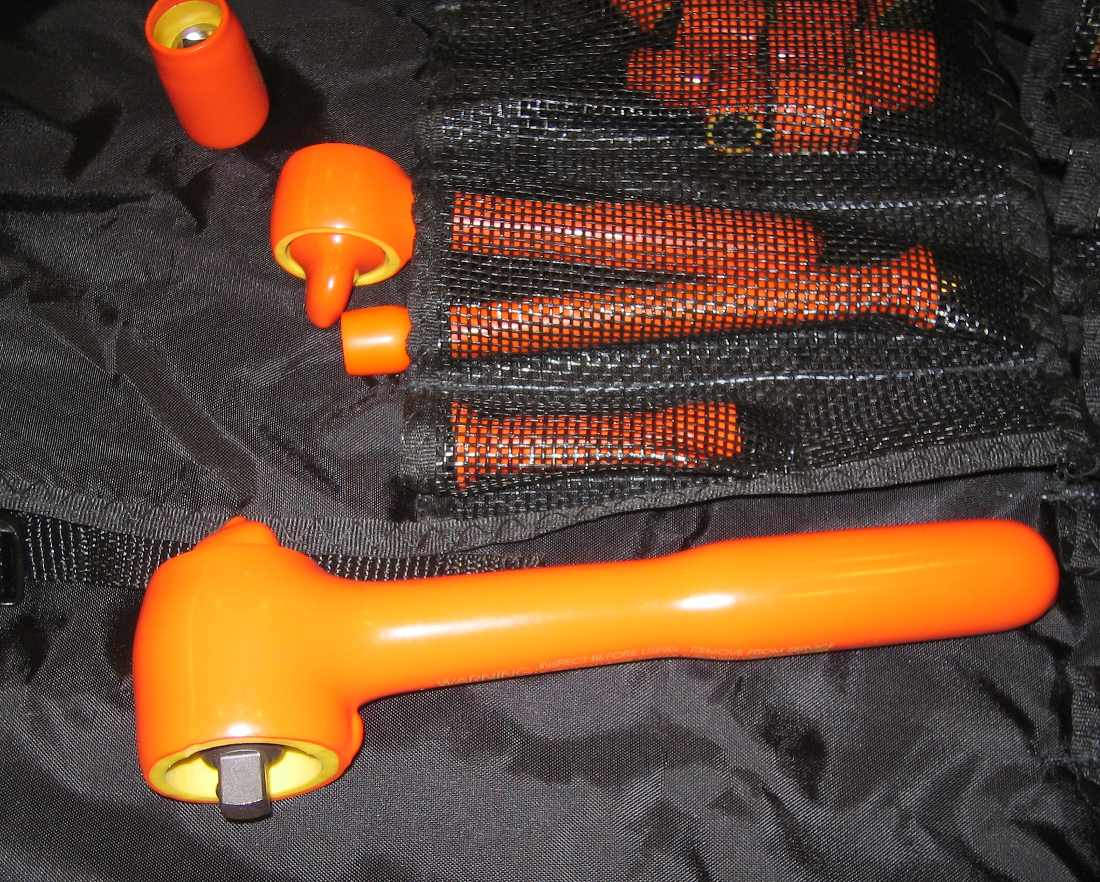
that apply.

____ CAT III meter

____ High-voltage gloves

____ Insulated tools

____ Other (describe) ___________

_______________________

_______________________

_______________________

