TOOT and SAI
Meets ASE Task: (A4-E-4 [P-2]and A4-E-5 [P-2) Check toe-out-on-turns (turning radius) and SAI (steering axis inclination) and included angle; determine necessary action.

Name _______________________________ Date ___________ Time on Task __________

Make/Model/Year _________________ VIN ________________ Evaluation: 4 3 2 1

_____ 1. Check the alignment equipment instructions and measure the toe-out-on-turns.

LEFT TOOT RIGHT TOOT

___________ _____________
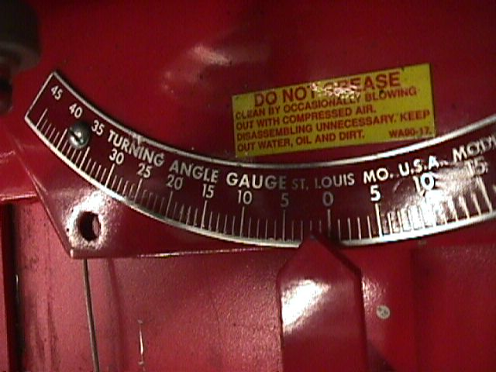
_____ 2. Check service information for the specified toe-out-on-turns
(TOOT).

Specifications = ____________________________

_____ 3. Based on the TOOT readings, what is the necessary action?

__________________________________________________________________

__________________________________________________________________

_____ 4. Check steering axis inclination (SAI) and compare to factory specifications.

SAI LEFT SAI RIGHT

_________ __________

Specification for SAI = ________________________________

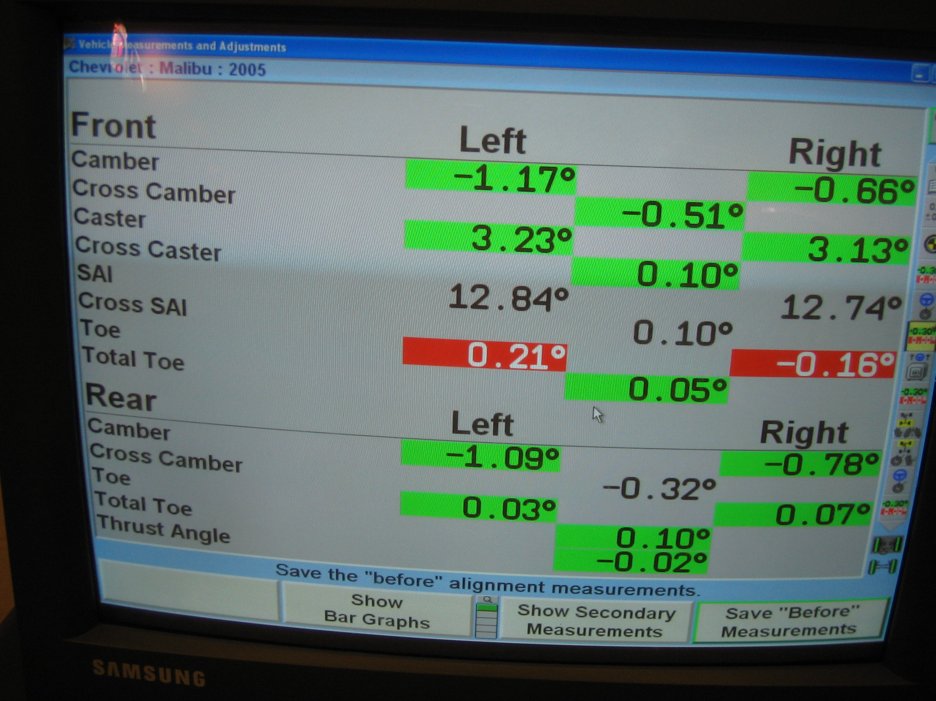
_____ 5. Based on the SAI reading, what is the
necessary action?

__________________________________

__________________________________

__________________________________

__________________________________

