Service Power Steering Pump
Meets ASE Task: (A4-B-12 [P-1], A4-B-13 [P-2], A4-B-14 [P-2], A-4-D-3 [P-3]) Remove, inspect, replace, and adjust power steering pump belt and pump; press fit pump pulley.

Name _______________________________ Date ___________ Time on Task __________

Make/Model/Year _________________ VIN ________________ Evaluation: 4 3 2 1

_____ 1. Check service information for the specified procedures and specifications for
removing, replacing, and adjusting the power steering pump and drive belt. Describe
the recommended procedure.

__________________________________________________________________

__________________________________________________________________

Specified belt tension = ____________________
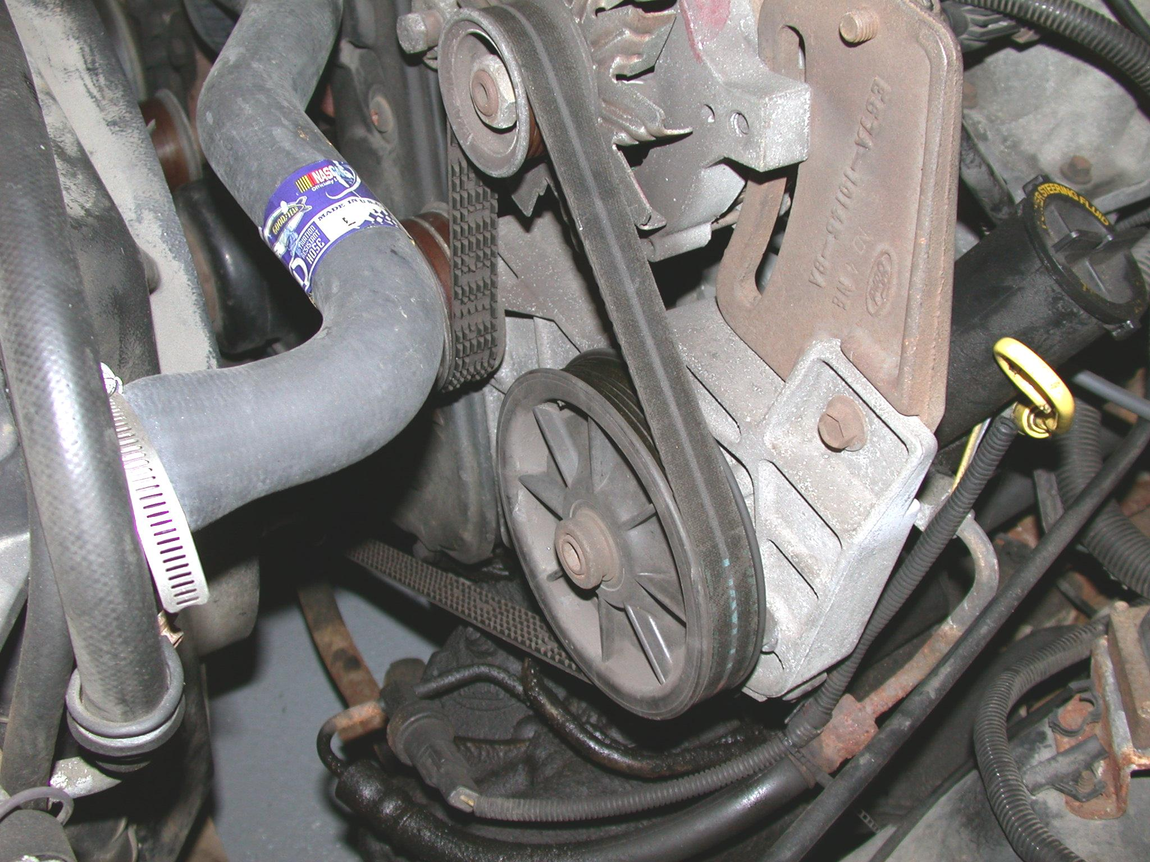
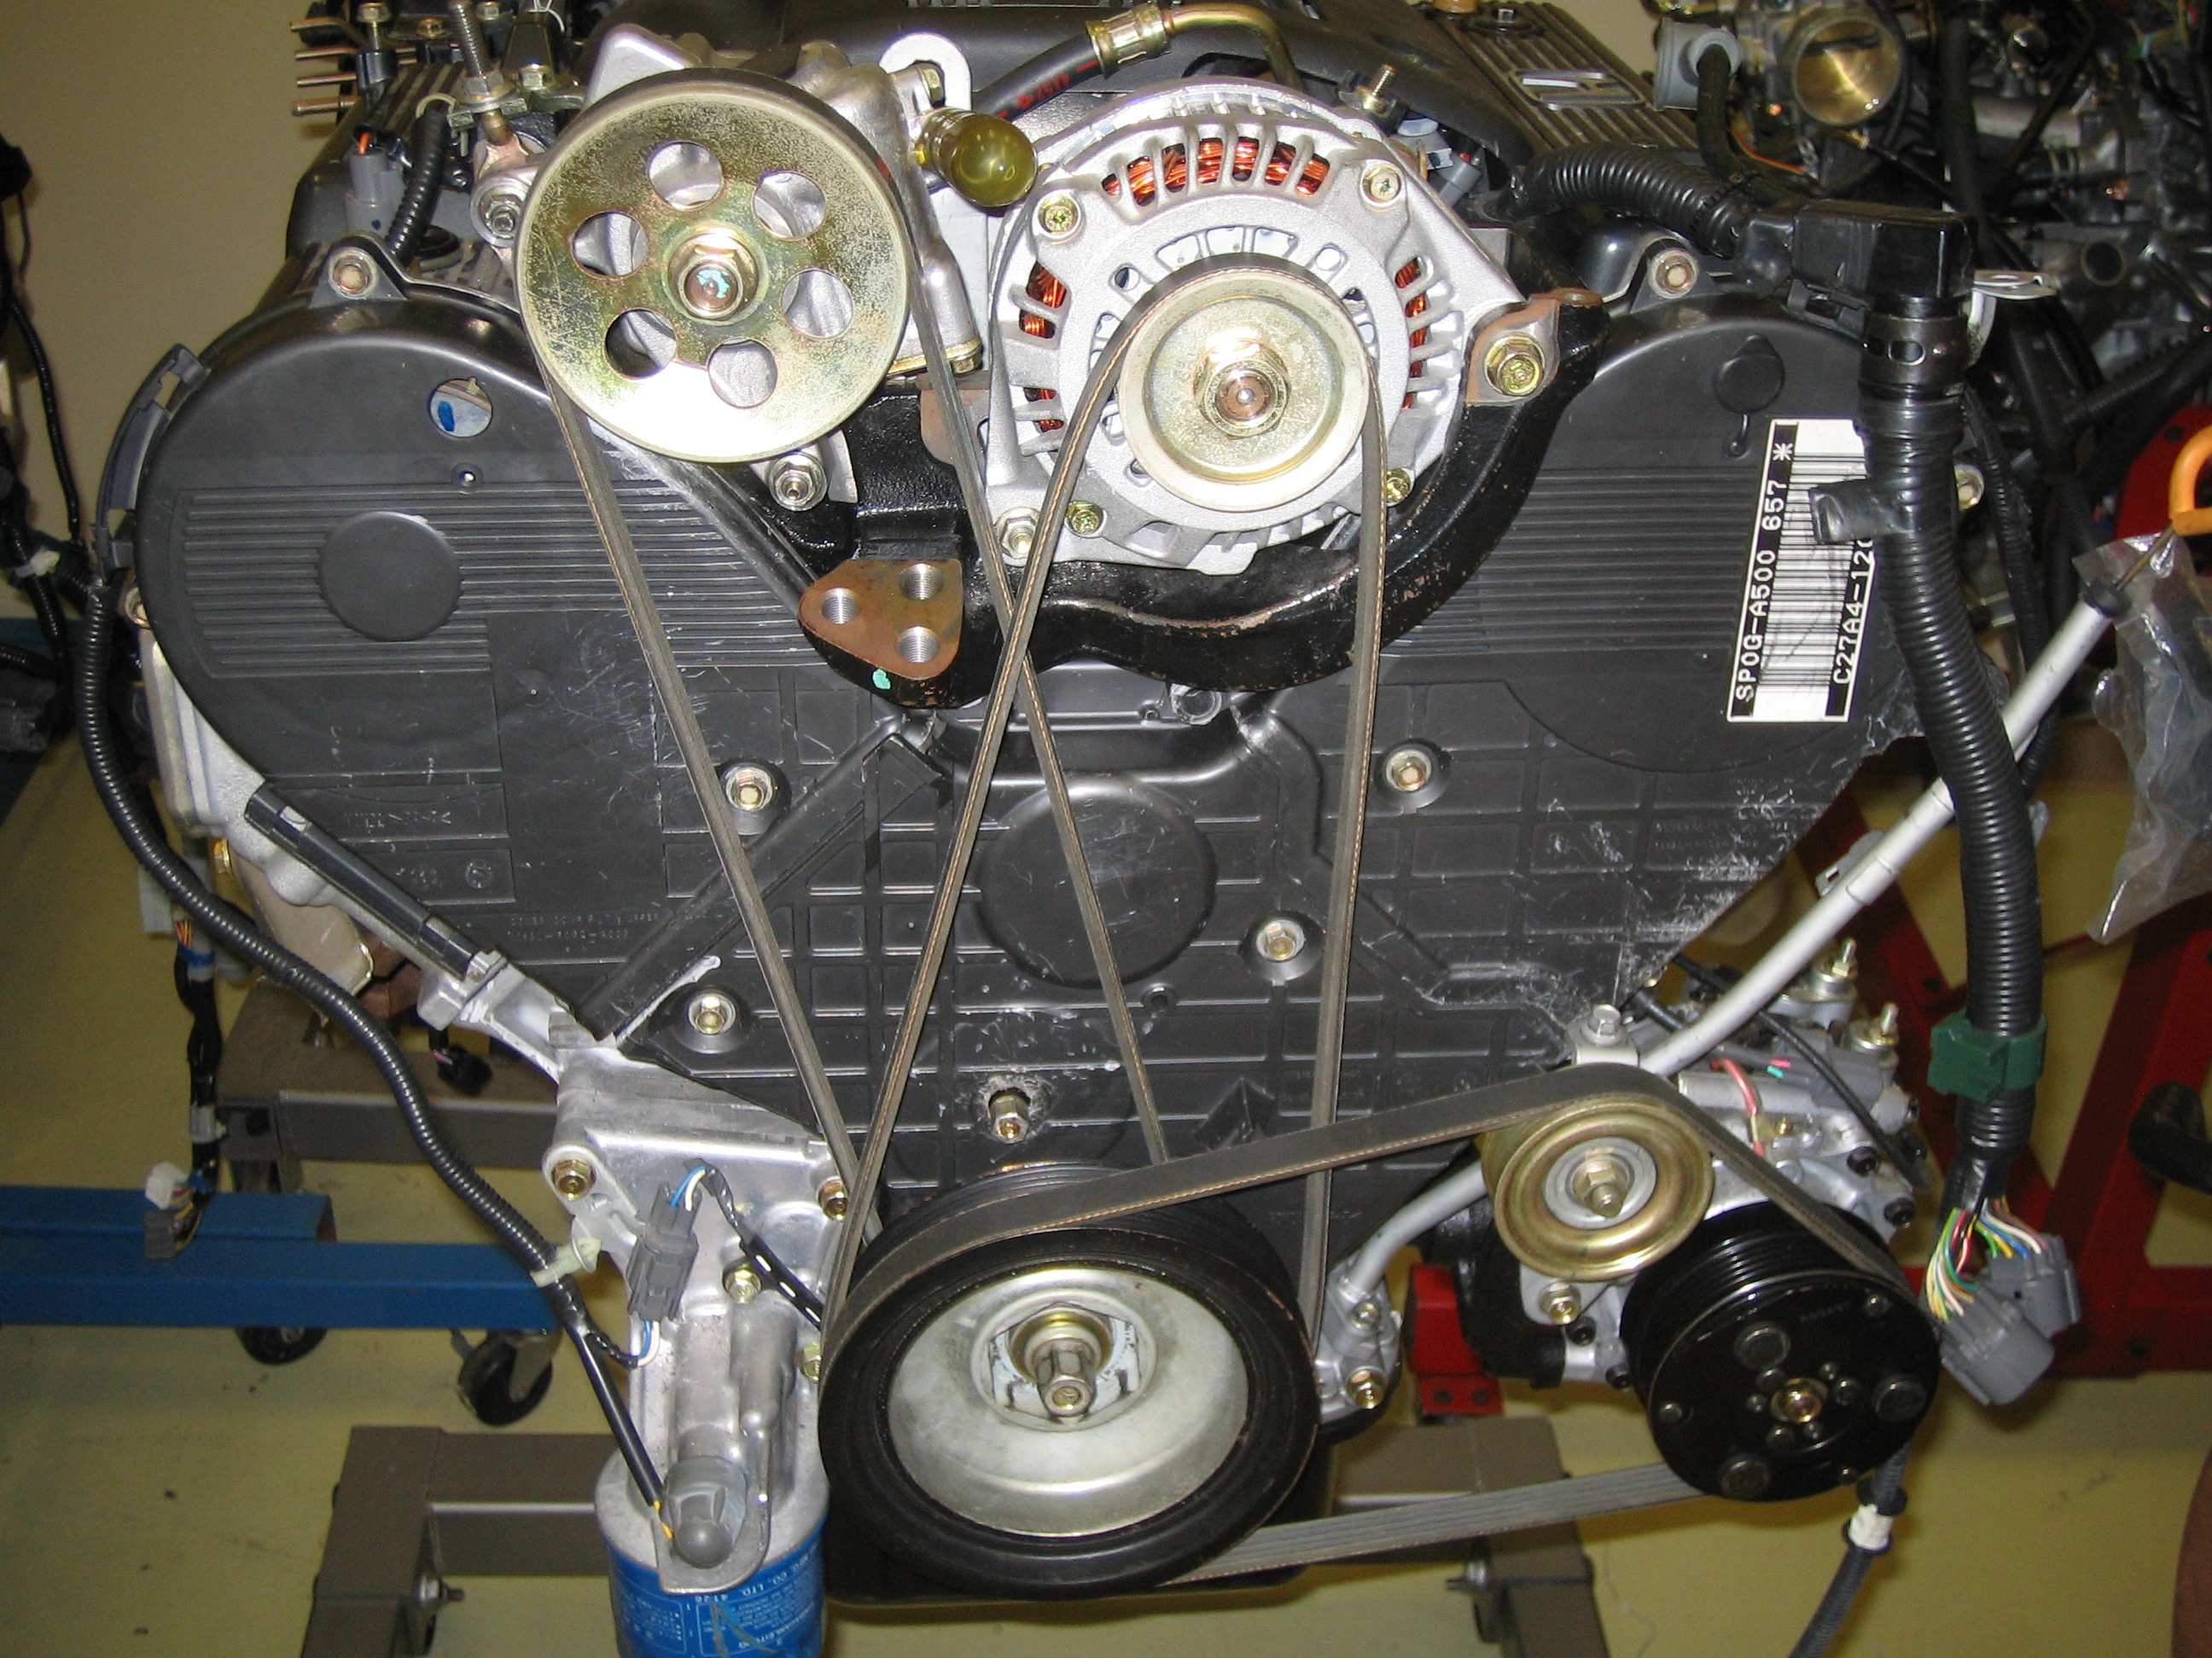

_____ 2. Remove and reinstall power steering pump assembly. Instructor check __________

_____ 3. Check service information for the specified procedure to follow to remove and
reinstall the power steering pump drive pulley. Describe the recommended procedure.

__________________________________________________________________

__________________________________________________________________

List the tools required. _______________________________________________

_____ 4. Describe the function of the power steering pressure switch. ____________________

_________________________________________________________________

