Starter Circuit Voltage Drop
Meets ASE Task: (A6-C-2) Perform starter circuit voltage drop tests; determine needed action. (P-1)

Name _______________________________ Date ___________ Time on Task __________

Make/Model/Year _________________ VIN ________________ Evaluation: 4 3 2 1

_____ 1. Set the digital multimeter to DC volts.

HINT: A voltmeter measures the difference in electrical pressure between the test leads. When the meter leads are connected to two locations and the engine is cranked, the meter will display the difference in voltage between the two points. This difference is called the voltage drop.

_____ 2. Disable the ignition system or the fuel system to keep the engine from starting.

_____ 3. Connect the voltmeter, as shown in the illustration, and crank the engine. Observe the
voltmeter.

_____ 4. All test results should be less than 0.2 V (200 mV).
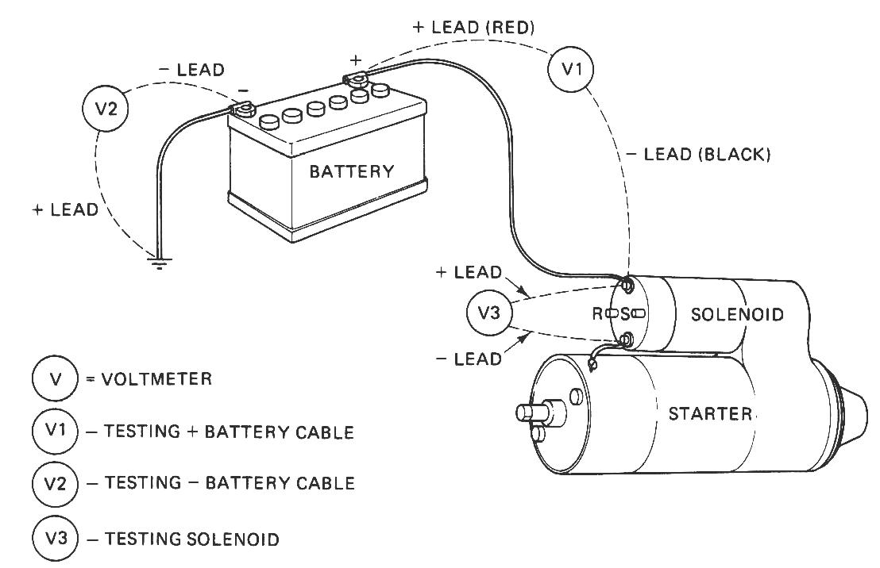
RESULTS:

_____ALL OK
_____ALL NOT OK

_____ 5. Based on the results of the voltage drop tests, what is the needed action?

__________________________________________________________________

__________________________________________________________________

