Battery Specifications
Meets ASE Task: Not specified by ASE.

Name _______________________________ Date ___________ Time on Task __________

Make/Model/Year _________________ VIN ________________ Evaluation: 4 3 2 1

_____ 1. Determine the following information about the battery.
A. Cold cranking amperes (CCA) rating = ______ (usually 500-1000)
B. Cranking amperes (CA) rating = ______ (usually 500-1000)
C. Reserve capacity rating (in minutes) = ______ (usually 50-200)
_____ 2. What are the recommended load test amperes?
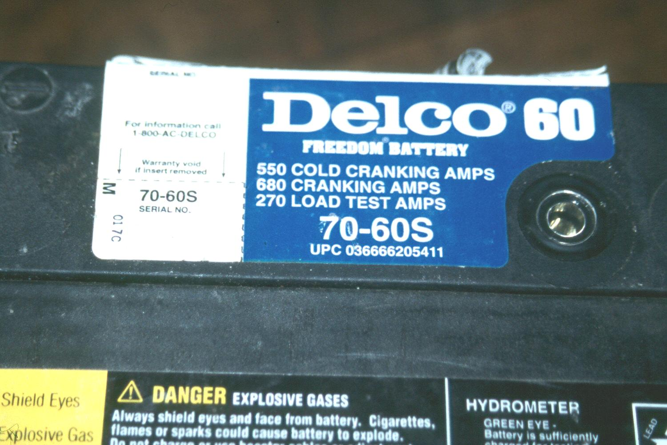
_______ A (normally 1/2 of CCA rating)
_____ 3. Size of the battery:
Height = __________
Length = __________
Width = __________
_____ 4. Type of terminals:
_____ Side terminals
_____ Top terminals
_____ Both side and top terminals
_____ 5. Determine the age of the battery from the shipping date sticker or other codes.
Sticker = ______________________
_____ Less than 1 year old
_____ 1 to 3 years old
_____ 3 to 5 years old
_____ Older than 5 years
_____ Unknown

