**CV Joint Noise and Vibration Diagnosis**

**Meets ASE Task:** (A3-D-1) P-2, (A3-D-2) P-2, (A3-D-5) P-2 Diagnose constant-velocity (CV) joint noise and vibration concerns; determine needed action.

**Name _______________________________ Date ___________ Time on Task __________**

**Make/Model/Year _________________ VIN ________________ Evaluation: 4 3 2 1**

**_____ 1.** Check service information for the specified procedure that should be followed when

diagnosing CV joint noise and/or vibration concerns.

__________________________________________________________________

__________________________________________________________________

**_____ 2.** Check all that were specified:

___ Drive backward while turning ___ Drive in a circle to the left and right

___ Drive forward while turning ___ Drive at highway speed

___ Drive forward straight ahead ___ Drive in reverse straight ahead

___ Other (specify) _______________________________________________

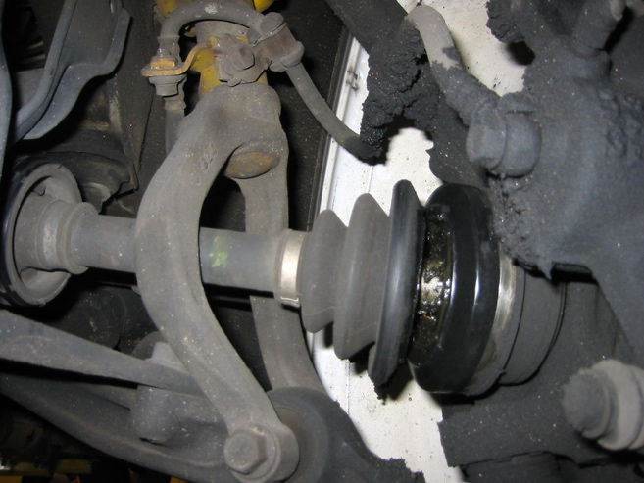

**_____ 3.** Most vehicle manufacturers specify that the engine and transmission/transaxle mounts

be checked for damage or wear. What are the conditions of the mounts?

__________________________________________________________________

**_____ 4.** Based on the inspection and testing, what is the needed action? __________________

__________________________________________________________________