Inspect Power Steering Hoses and Fittings

Meets ASE Task: (A4-B-15) P-2 Inspect and replace power steering hoses and fittings.

Name _______________________________ Date ___________ Time on Task __________

Make/Model/Year _________________ VIN ________________ Evaluation: 4 3 2 1

_____ 1. Check the service information for the specified procedures, precautions, and torque
specifications.
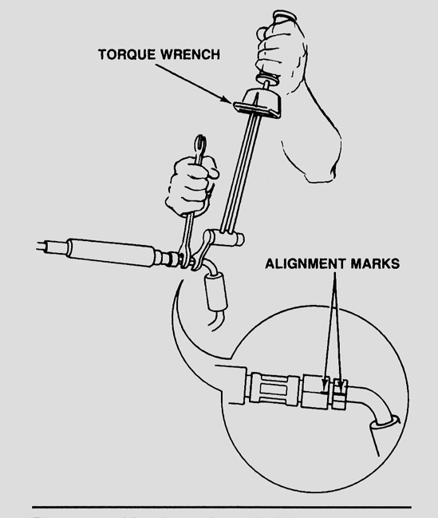
A. Specified procedure: _________________
__________________________________
B. Specified precautions: ________________
__________________________________
C. Specified torque specifications _________
__________________________________

_____ 2. Check the reason why the hoses and/or fittings are
being replaced.

____ Leaking
____ Worn outside cover
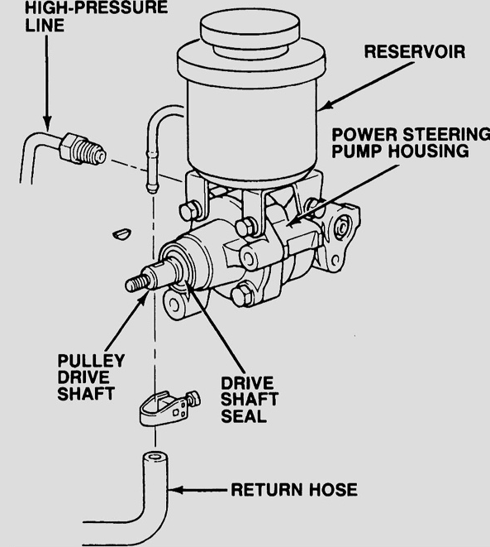
____ Possible restriction as determined by testing
____ Recommended when replacing pump or
gear assembly
____ Other (specify) ____________________
________________________________

_____ 3. Which hose(s) or fitting(s) was replaced?

____ High-pressure hose and fitting
____ Low-pressure hose and fitting
____ Other (specify) ____________________
_________________________________

