Service Power Steering Pump

Meets ASE Task: (A4-B-13) P-1, (A4-B-14) P-2 Remove, inspect, replace, and adjust power steering pump belt and pump; press fit pump pulley.

Name _______________________________ Date ___________ Time on Task __________

Make/Model/Year _________________ VIN ________________ Evaluation: 4 3 2 1

_____ 1. Check service information for the specified procedures and specifications for

removing, replacing, and adjusting the power steering pump and drive belt. Describe

the recommended procedure.

__________________________________________________________________

__________________________________________________________________

Specified belt tension = ____________________
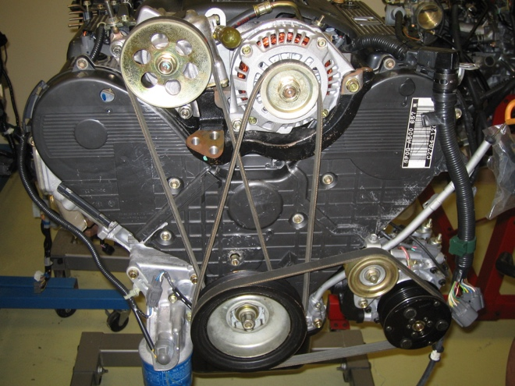
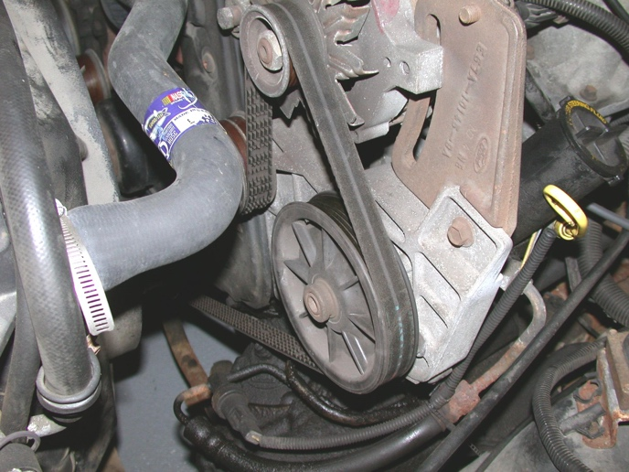

_____ 2. Remove and reinstall power steering pump assembly. Instructor check __________

_____ 3. Check service information for the specified procedure to follow to remove and

reinstall the power steering pump drive pulley. Describe the recommended procedure.

__________________________________________________________________

__________________________________________________________________

List the tools required. _______________________________________________

Instructor check __________

