**Power Steering Pump Belt**

Meets ASE Task: (A4-B-12) P-1 Remove, inspect, replace and/or adjust power steering pump drive belt.

**Name _______________________________ Date ___________ Time on Task __________**

**Make/Model/Year _________________ VIN ________________ Evaluation: 4 3 2 1**

**_____ 1.** Check service information for the specified procedure and specifications when

inspecting, replacing, and/or adjusting the power steering pump drive belt. Describe

the specified procedure. _________________________________________________

__________________________________________________________________

__________________________________________________________________

**_____ 2.** How many grooves on the pulley belt: ______________________

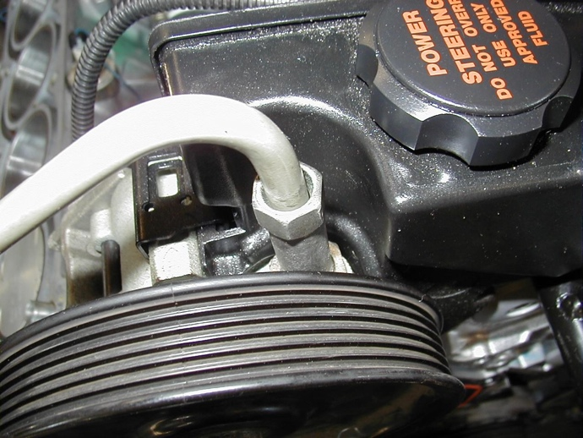

**_____ 3.** Does the power steering pump drive belt use a tensioner? ___ Yes ___No

If yes, does service information specify a tension test procedure?

_______ ___________________________________________________________

__________________________________________________________________

__________________________________________________________________

