Power Steering Fluid

Meets ASE Task: (A4-B-9) P-1, (A4-B-10) P-2 Determine proper fluid and flush power steering system.

Name _______________________________ Date ___________ Time on Task __________

Make/Model/Year _________________ VIN ________________ Evaluation: 4 3 2 1

_____ 1. Check service information for the specified fluid to use in the power steering system.

Specified fluid = ________________________________________
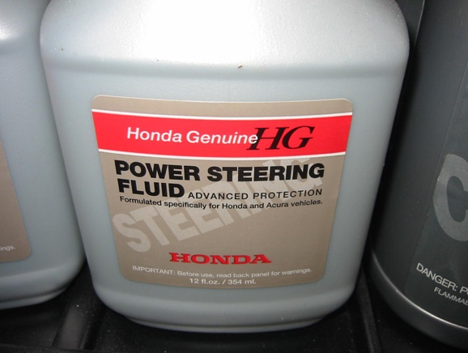

_____ 2. Check service information for the specified procedure to follow when flushing, filling,

and bleeding a power steering system. List the recommended steps:

Step 1 ______________________________________________________

Step 2 ______________________________________________________

Step 3 ______________________________________________________

Step 4 ______________________________________________________
