Steering Gear Diagnosis

Meets ASE Task: (A4-B-4) P-2, (A4-B-5) P-2 Diagnose conventional and rack and pinion steering gears; determine needed action.

Name _______________________________ Date ___________ Time on Task __________

Make/Model/Year _________________ VIN ________________ Evaluation: 4 3 2 1

_____ 1. Check service information for the specified procedure to follow when diagnosing

conventional steering gear mechanical and noise concerns. Describe the

recommended procedures.

_________________________________________________________________

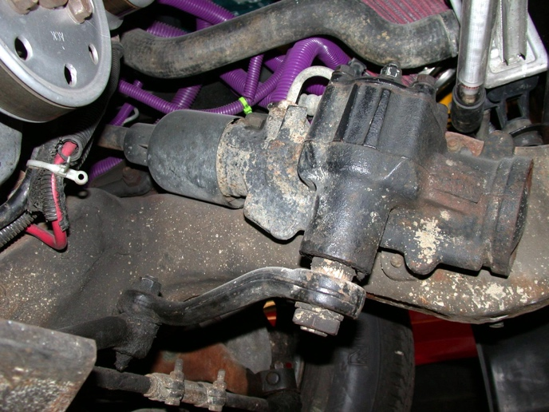
_________________________________________________________________

_____ 2. Check service information for the specified procedures to follow when diagnosing a

rack and pinion steering gear assembly. Describe the recommended procedures.
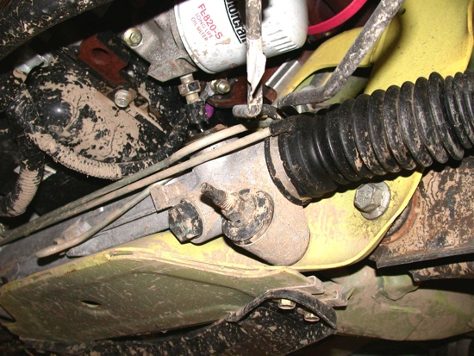

______________________________________

______________________________________

______________________________________

_____ 3. Based on the diagnosis, what is the needed action?

_______________________________________

