Fire Extinguisher

Meets ASE Task: (Not specified by ASE)

Name _______________________________ Date ___________ Time on Task __________

Make/Model/Year _________________ VIN ________________ Evaluation: 4 3 2 1

_____ 1. Describe the location of the fire extinguishers in your building or shop and note the

last inspection dates.

Type of Extinguisher Location Inspection Date

_____________________ ______________________ ________________

_____________________ ______________________ ________________

_____________________ ______________________ ________________

_____________________ ______________________ ________________

_____ 2. Do any of the fire extinguishers need to be charged?

_____ Yes (which ones) _____________________________________________

_____ No

_____ 3. Where can the fire extinguishers be recharged? List the name and telephone number

of the company. __________________________________ ____________________

_____ 4. What is the cost to recharge the fire extinguishers?
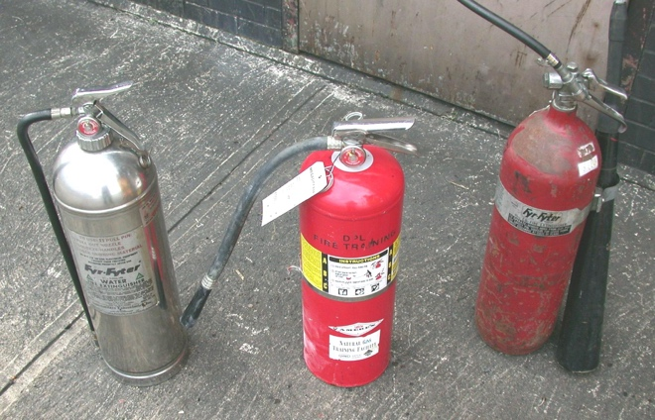

a. Water = __________________

b. CO₂ = __________________

c. Dry chemical = __________________

