Inspect and Replace Steering Components
Meets ASE Task: (A4-B-16) P-2, (A4-C-6) P-3 Inspect and replace pitman arm, relay (centerlink/intermediate) rod, idler arm and mountings, and steering linkage damper.

Name _______________________________ Date ___________ Time on Task __________

Make/Model/Year _________________ VIN ________________ Evaluation: 4 3 2 1

_____ 1. Check the service information for the specified testing and inspection procedures and
specifications.
A. Specified testing procedures: ______________________________________
______________________________________________________________
B. Specifications: __________________________________________________
______________________________________________________________
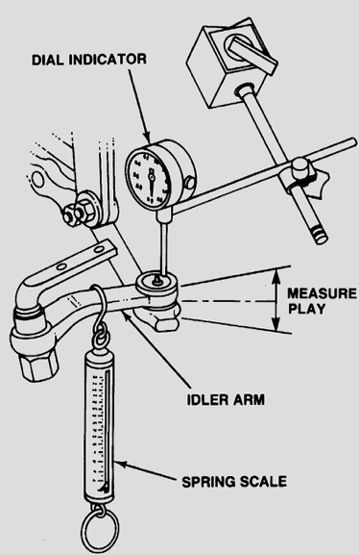
_____ 2. Check the steering components listed and note their
condition.
Idler arm: ______________________________
________________________________
Pitman arm: ____________________________
________________________________
Centerlink: ____________________________
________________________________
Steering linkage damper: _________________
________________________________
_____ 3. State the specified replacement procedure and list any specific tools needed.
Idler arm: Procedure _______________________________________________
Tools ___________________________________________________
Pitman arm: Procedure ______________________________________________
Tools ___________________________________________________
Centerlink: Procedure _______________________________________________
Tools ___________________________________________________
Steering linkage damper: Procedure ____________________________________
Tools __________________________________________________

