Steering Gear Adjustment and Replacement

Meets ASE Task: (A4-B-7) P-2 Adjust non-rack and pinion worm bearing preload and sector lash; Remove and replace rack and pinion steering gear.

Name _______________________________ Date ___________ Time on Task __________

Make/Model/Year _________________ VIN ________________ Evaluation: 4 3 2 1

_____ 1. Check service information for the specified procedure to follow to adjust a

conventional steering gear assembly Describe the recommended procedure for:

Worm bearing preload - ___________________________________________

_________________________________________________________

Sector lash (overcenter adjustment) - _________________________________

_________________________________________________________

_____ 2. Check service information for the specified procedure to follow for replacing a rack

and pinion steering gear assembly. Describe the recommended procedures.

________________________________________________________________

________________________________________________________________
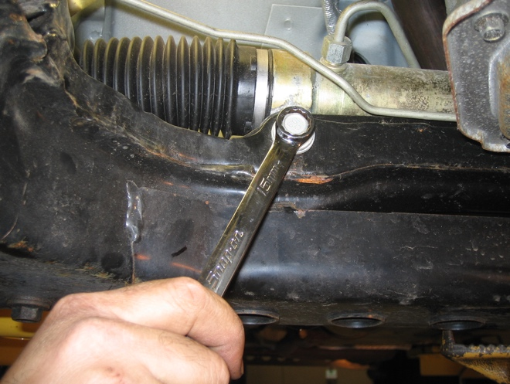

_____ 3. Describe the condition of the mounting bushings and brackets. __________________

__________________________________________________________________

