Inspect, Remove, or Replace Suspension Components

Meets ASE Task: (A4-C-11) P-3 Inspect, remove and/or replace track bar, strut rods/radius arms.

Name _______________________________ Date ___________ Time on Task __________

Make/Model/Year _________________ VIN ________________ Evaluation: 4 3 2 1

_____ 1. Check service information for the specified procedure to follow when inspecting and
replacing track bar and/or strut rods. Describe the specified procedure.
_________________________________________________________________
_________________________________________________________________
_________________________________________________________________

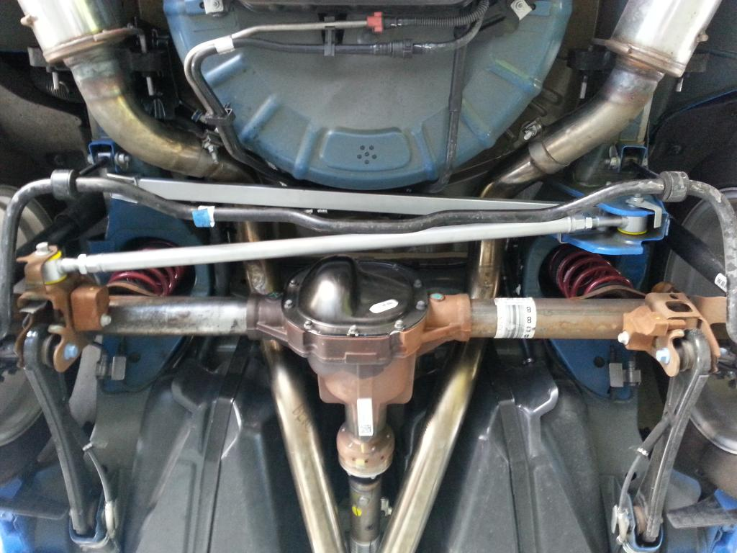

_____ 2. Describe the location of the track bar (if equipped). _________________________

________________________________________________________________

________________________________________________________________

_____ 3. Describe the location of the strut rods/radius arms (if equipped). ________________

________________________________________________________________

________________________________________________________________

