Rear Leaf Springs
Meets ASE Task: (A4-C-12) P-1 Remove, inspect, and install leaf springs, leaf spring insulators (silencers), shackles, brackets, bushings, and mounts.

Name _______________________________ Date ___________ Time on Task __________

Make/Model/Year _________________ VIN ________________ Evaluation: 4 3 2 1

_____ 1. Check the service information for the specified procedure for the removal and
reinstallation of rear leaf springs.

_______________________________________________________________
_______________________________________________________________
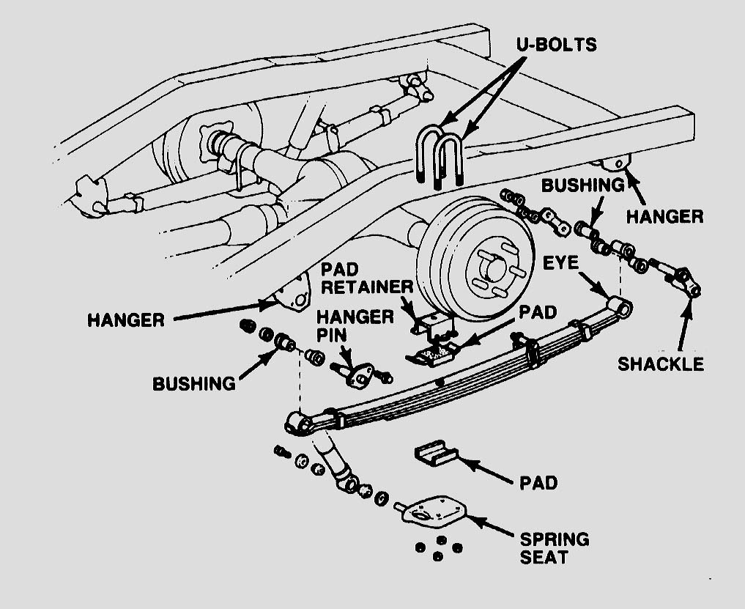
_______________________________________________________________

_____ 2. List the tools and equipment needed. _____________________________________
________________________________________________________________

_____ 3. Show the instructor the removed rear leaf spring(s). Instructor’s OK ____________

_____ 4. List the tightening torque specifications for the affected fasteners. ________________
__________________________________________________________________

