Shock Absorber/Strut Cartridge Replacement

Meets ASE Task: (A4-C-10) P-3 Inspect, test, and replace thermostat and gasket/seal.

Name _______________________________ Date ___________ Time on Task __________

Make/Model/Year _________________ VIN ________________ Evaluation: 4 3 2 1

_____ 1. Check service information for the specified procedure to follow when inspecting,

removing, and replacing shock absorbers. Describe recommended steps.

__________________________________________________________________

__________________________________________________________________
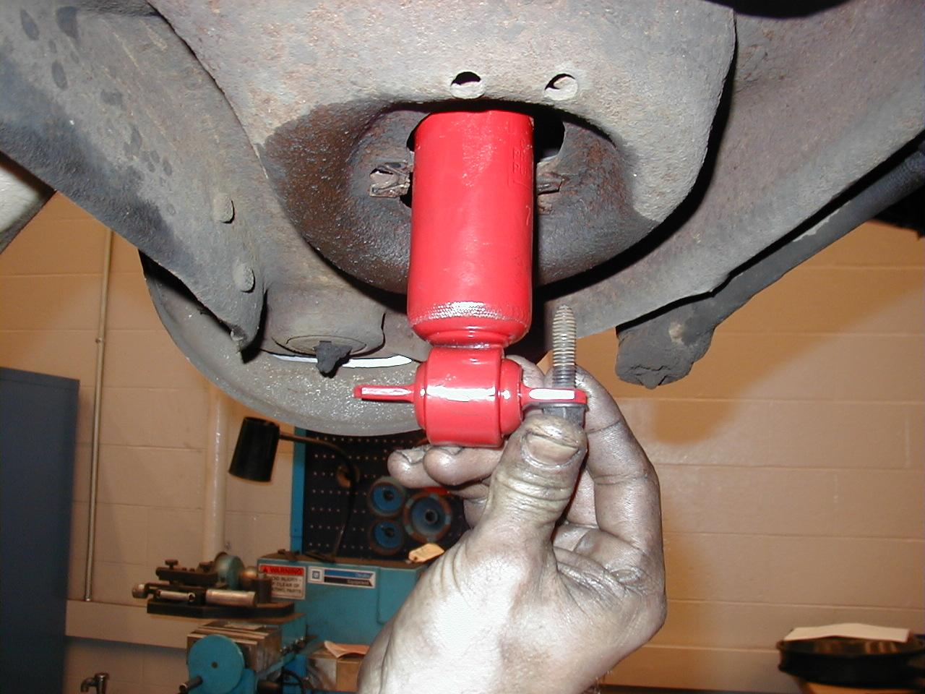

_____ 2. Instructor OK after removal ___________

_____ 3. Check service information for the specified procedures to follow when inspecting,

removing, and replacing strut cartridges. Describe the recommended steps.
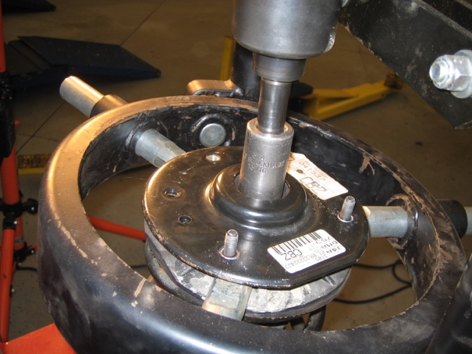

___________________________________

___________________________________

___________________________________

___________________________________

_____ 4. Instructors OK after removal _______________

