MacPherson Strut Service
Meets ASE Task: (A4-C-10) P-3 Remove, inspect, and install strut cartridge or assembly, strut coil spring, insulators (silencers), and upper strut bearing mount.

Name _______________________________ Date ___________ Time on Task __________

Make/Model/Year _________________ VIN ________________ Evaluation: 4 3 2 1

_____ 1. Check the service information for the specified service procedure.

_______________________________________________________________
_______________________________________________________________
_______________________________________________________________
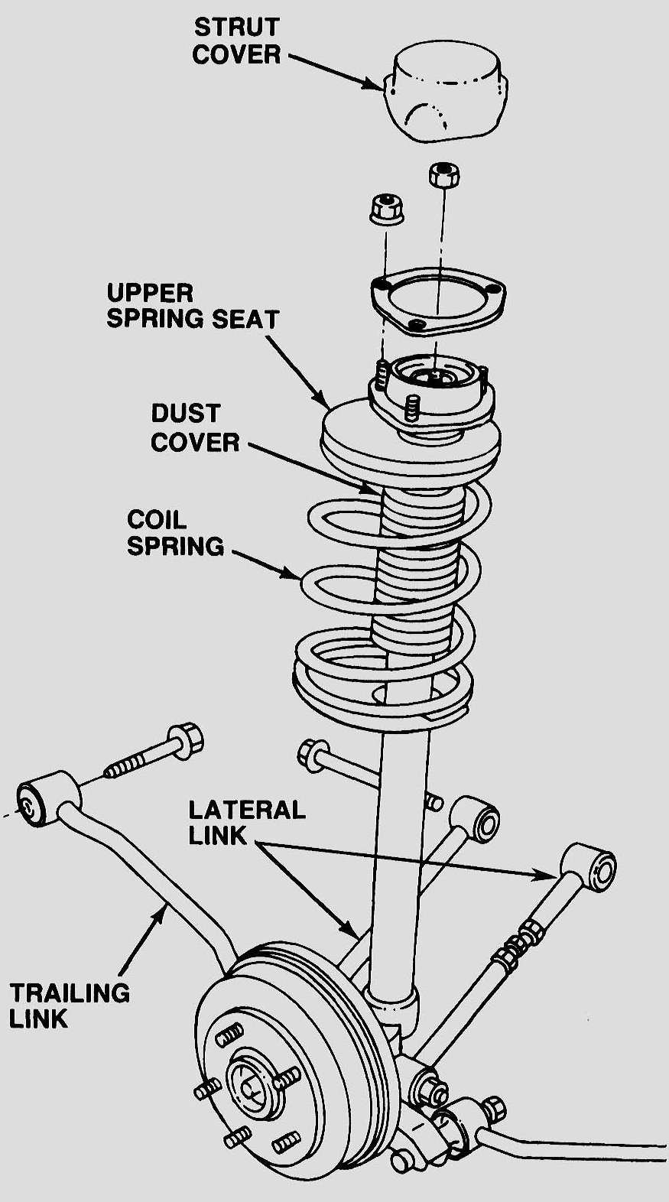
_____ 2. Safely support the vehicle on jacks and/or the
lift.

_____ 3. Remove the upper and lower attaching bolts
and nuts.

_____ 4. Carefully remove the MacPherson
strut assembly from the vehicle.

_____ 5. Compress the coil spring with the proper
equipment and replace the strut assembly.

Show the instructor the disassembled unit.

Instructor's OK _________

_____ 6. Reinstall the complete assembly.

NOTE: The vehicle should be aligned after replacing the strut assembly.

