Strut Rod and Stabilizer Bushings

Meets ASE Task: (A4-C-9) P-3 Inspect, test, and replace thermostat and gasket/seal.

Name _______________________________ Date ___________ Time on Task __________

Make/Model/Year _________________ VIN ________________ Evaluation: 4 3 2 1

_____ 1. Check service information for the exact procedure to follow to remove, inspect, and

install struts and bushings. Describe the recommended steps.

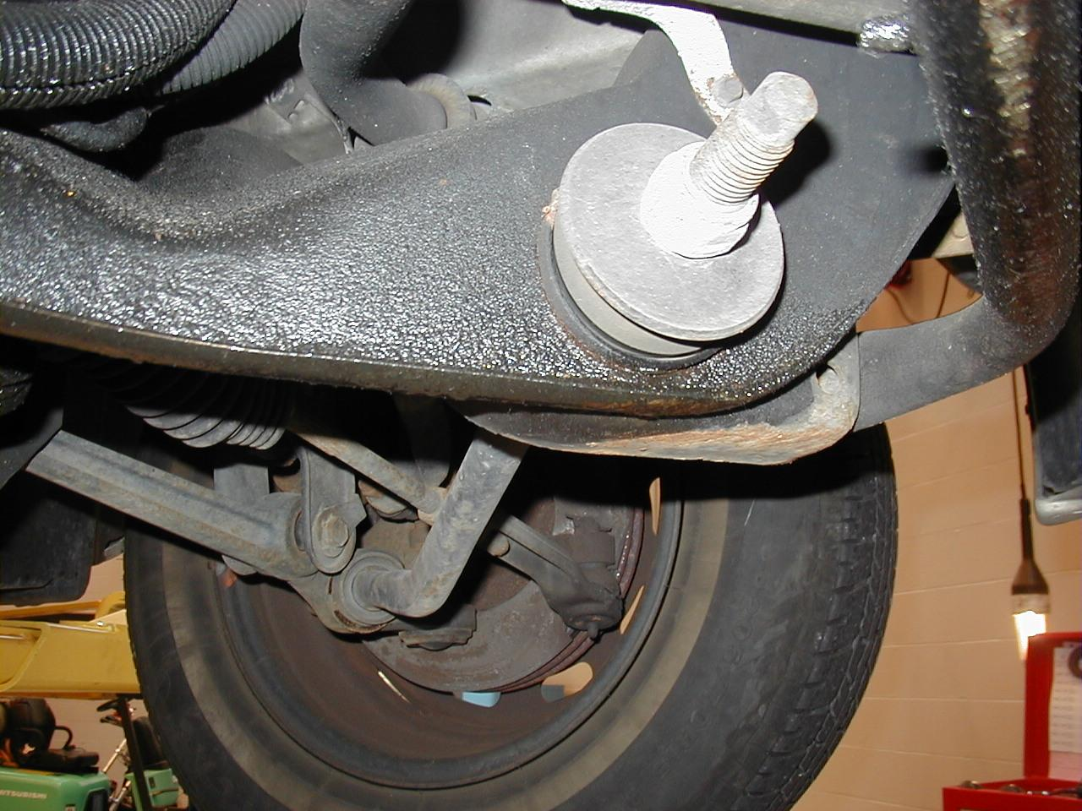
_____________________________

_____________________________

_____________________________

_____________________________

_____________________________

_____________________________

_____________________________

_____ 2. Check service information for the exact procedures to follow to remove, inspect, and

install stabilizer bar bushings. Describe the recommended steps.






