Torsion Bar

Meets ASE Task: (A4-C-8) P-3 Remove, inspect, install, and adjust suspension system torsion bars; inspect mounts.

Name _______________________________ Date ___________ Time on Task __________

Make/Model/Year _________________ VIN ________________ Evaluation: 4 3 2 1

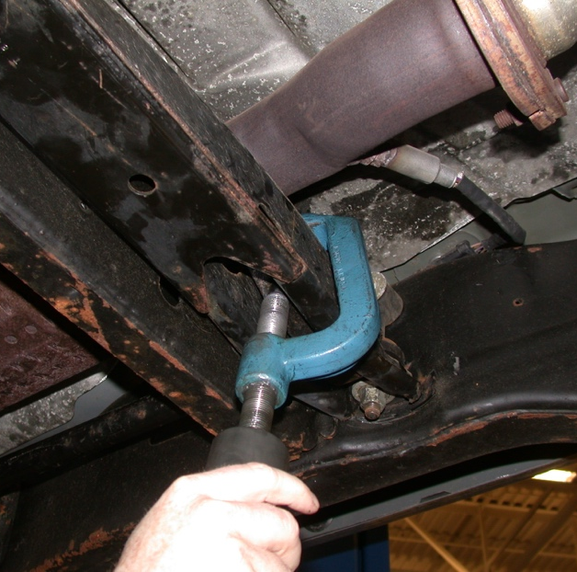
_____ 1. Check the service information for the specified
removal and reinstallation procedure.
__________________________________
__________________________________
__________________________________
__________________________________
_____ 2. List the tools needed.

_____________________________
_____________________________
_____________________________
_____________________________
_____________________________
_____ 3. Check the service information and describe
the proper ride height adjustment procedure.
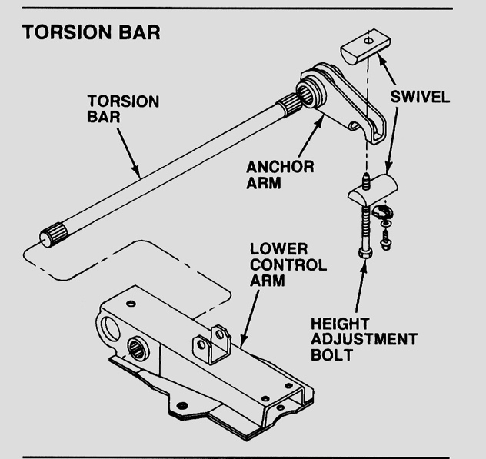
_____________________________
_____________________________
_____________________________
_____________________________
_____________________________
_____ 4. Inspect the torsion bar mounts.

OK ____ NOT OK ____

Describe the faults and needed action. _______________________________
_______________________________

