Suspension Inspection/Component Replacement

Meets ASE Task: (A4-C-3) P-3, (A4-C-4) P-3, (A4-C-5) P-2, (A4-C-6) P-3, (A4-C-7) P-3

Front suspension inspection and component replacement.

Name _______________________________ Date ___________ Time on Task __________

Make/Model/Year _________________ VIN ________________ Evaluation: 4 3 2 1

_____ 1. Check service information for the exact procedures to follow when removing,

inspecting, and replacing front suspension components. Describe the recommended

procedures.

__________________________________________________________________

__________________________________________________________________

_____ 2. Check all components that were inspected, removed or replaced.
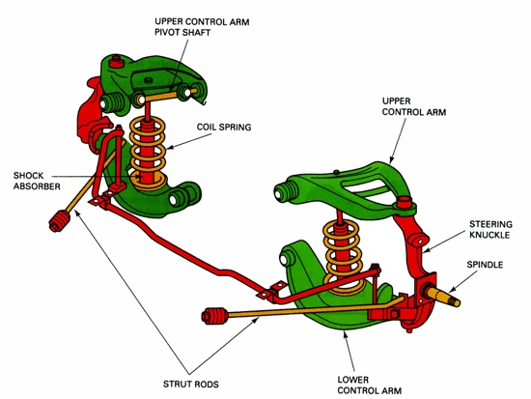

____ Upper control arms/bushings

____ Lower control arms/bushings

____ Strut rods/bushings

____ Steering knuckle

____ Coil springs and spring insulators

_____ 3. Describe the reason why the parts were replaced. _____________________________

__________________________________________________________________

