Diagnose Suspension Concerns

Meets ASE Task: (A4-C-1) P-1, (A4-C-2) P-2 Diagnose SLA and strut suspension concerns; determine needed action.

Name _______________________________ Date ___________ Time on Task __________

Make/Model/Year _________________ VIN ________________ Evaluation: 4 3 2 1

_____ 1. Check service information for the specified procedures to follow when diagnosing

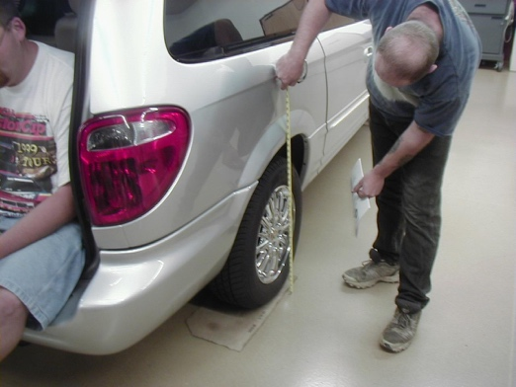
suspension-related concerns. Check all items that are specified.

____ Road Test

____ Visual inspection

____ Ride height measurement

____ Other (describe) ____________

_________________________

_____ 2. Based on the inspection, what is the needed action? ___________________________

__________________________________________________________________

__________________________________________________________________

__________________________________________________________________
