Research Vehicle Service Information

Meets ASE Task: (A4-A-1) P-1 Research vehicle service information.

Name _______________________________ Date ___________ Time on Task __________

Make/Model/Year _________________ VIN ________________ Evaluation: 4 3 2 1

_____ 1. Check service information and check the following for the vehicle being serviced.
- Power steering fluid type __________________________________
- Technical service bulletin (list all that apply). _______________________
____________________________________________________________
____________________________________________________________
____________________________________________________________
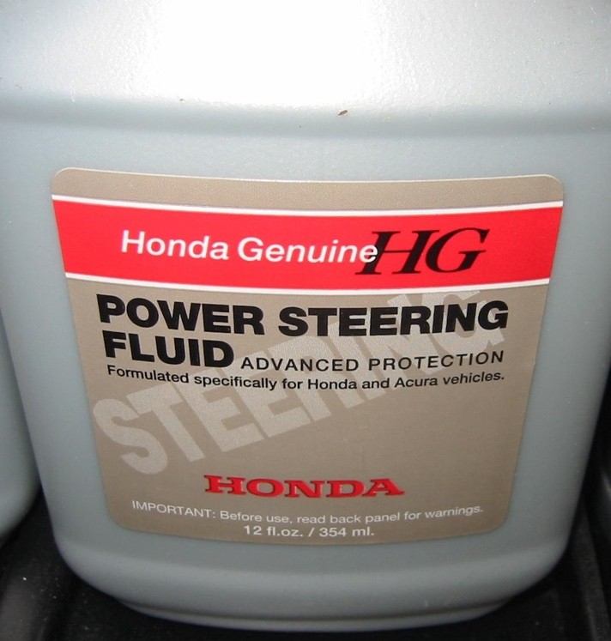

- Service precautions (list all that apply). ____________________________
____________________________________________________________
____________________________________________________________
____________________________________________________________

