Tire Replacement

Meets ASE Task: (A4-F-6) P-1 Dismount and remount tire on wheel; balance.

Name _______________________________ Date ___________ Time on Task __________

Make/Model/Year _________________ VIN ________________ Evaluation: 4 3 2 1

_____ 1. Check the instructions for the proper use of the tire changer. Describe the

recommended procedure.

__________________________________________________________________

__________________________________________________________________

_____ 2. Check all steps that were performed.

____ Removed the valve core (TPMS equipped tire/wheel assembly; check

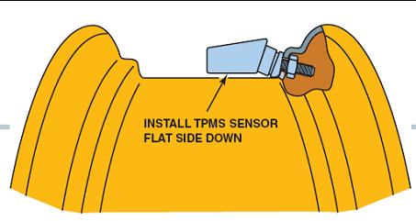
service information for the exact procedure to follow.)

____ Demount the tire from the wheel. Instructor OK __________________

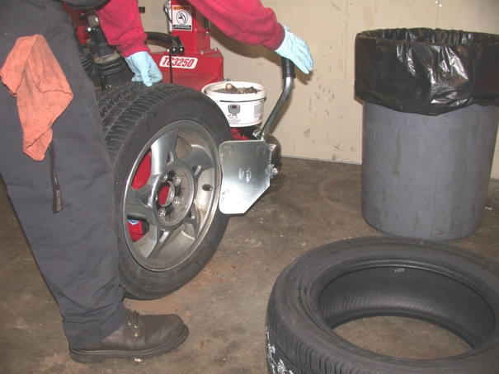
____ Clean bead seat.

____ Lubricate the tire bead.

____ Mount the tire and inflate to

specified inflation pressure.

_____ 3. Balance tire/wheel assembly.

Instructor OK __________________

