Tire, Wheel, Axle, and Hub Runout
Meets ASE Tasks: (A4-F-4) P-2 Measure wheel, tire, axle flange, and hub runout;
determine needed action.

Name _______________________________ Date ___________ Time on Task __________

Make/Model/Year _________________ VIN ________________ Evaluation: 4 3 2 1

_____ 1. Check service information for the specifications for radial and lateral runout.
Specification for radial runout = _________ (usually less than 0.060 inch).
Specification for lateral runout = _________ (usually less than 0.045 inch).
_____ 2. Using a runout gauge, rotate the tire and record the radial runout (roundness of the
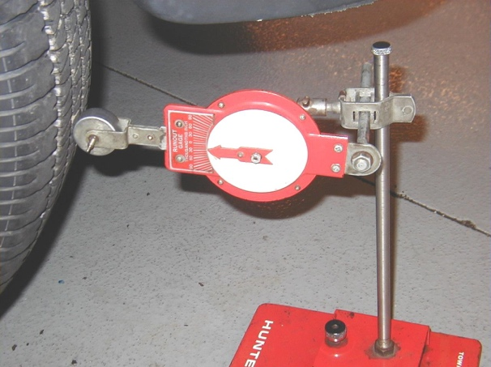
tires) and the lateral runout (side-to-side movement) of the tires.
Tire Radial Runout Lateral Runout
R.F. ______ _______
R.R. ______ _______
L.F. ______ _______
L.R. ______ _______
_____ 3. Using a dial indicator, measure the axle and hub runout.
Hub runout = ________ OK ____ NOT OK ____
Flange runout = ________ OK ____ NOT OK ____
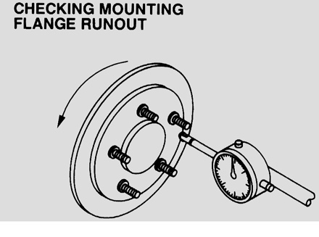
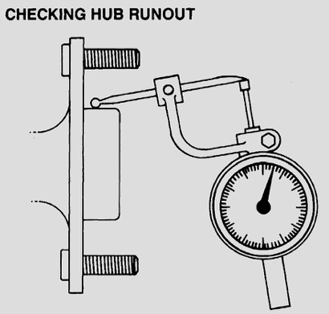

_____ 4. Based on the measurements, what needed action is needed?
______________________________________________________________
______________________________________________________________

