Tire Rotation
Meets ASE Tasks: (A4-F-3) P-1 Rotate tires according to manufacturer’s
recommendations.

Name _______________________________ Date ___________ Time on Task __________

Make/Model/Year _________________ VIN ________________ Evaluation: 4 3 2 1

_____ 1. Check the service information for the recommended tire rotation method.

_____ Cannot rotate tires on this vehicle
_____ Modified X method
_____ X method
_____ Front to rear and rear to front
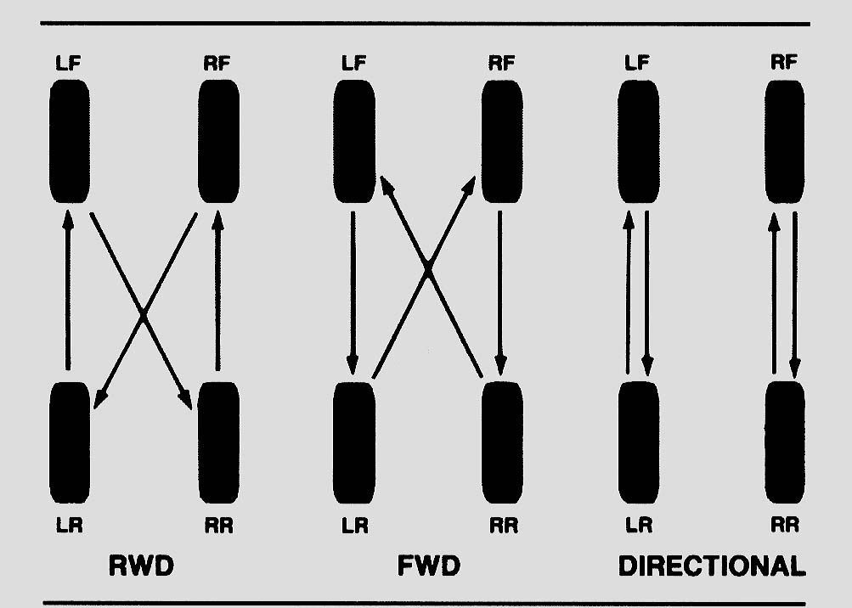

_____ 2. Hoist the vehicle safely to a good working position (chest level).

_____ 3. Remove the wheels and rotate them (if possible) according to the vehicle
manufacturer’s recommendation.

_____ 4. Check and correct the tire air pressures according to the service information on the
placard on the driver’s door.

Specified front tire air pressure = ________

Specified rear tire air pressure = ________

_____ 5. Tighten the lug nuts to factory specifications. What is the factory specification?
________________________

_____ 6. Lower the vehicle and move the hoist pads before driving the vehicle out of the
service stall.

