Tire Vibration and Pull Diagnosis

Meets ASE Task: (A4-F-2) P-2, (A4-F5) P-1 Diagnose vibration and pull concerns; determine needed action.

Name _______________________________ Date ___________ Time on Task __________

Make/Model/Year _________________ VIN ________________ Evaluation: 4 3 2 1

_____ 1. Check service information for the specified procedures to follow when diagnosing

vibration and pull concerns. Describe the recommended procedures.

________________________________________________________________

________________________________________________________________

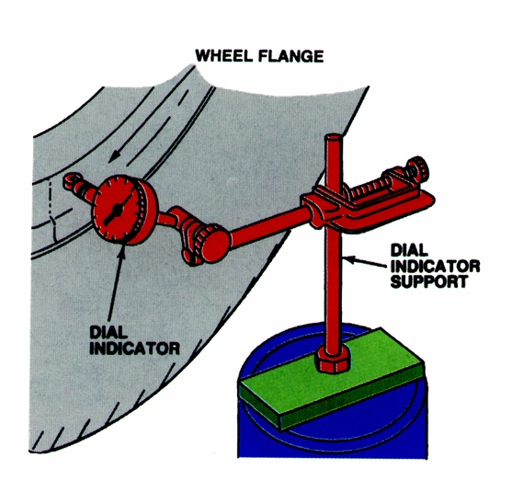
_____ 2. Check all that are specified:

____ Test drive

____ Use an electronic vibration analyzer (EVA)

____ Visual inspection

____ Measure radial runout ______________

____ Measure lateral runout ______________

____ Rotate tires

____ Other (describe) _______________________________________________

____________________________________________________________

_____ 3. Based on the diagnostic procedures, what is the needed action?

__________________________________________________________________

__________________________________________________________________

