Tire Pressure Monitoring System

Meets ASE Task: (A4-F-7) P-1, (A4-F-10) P-1, (A4-F-11) P-1 Inspect, diagnose and calibrate tire pressure monitoring system.

Name _______________________________ Date ___________ Time on Task __________

Make/Model/Year _________________ VIN ________________ Evaluation: 4 3 2 1

_____ 1. Check service information to determine the specified procedure to follow when

inspecting, diagnosing, or calibrating the tire pressure monitoring system. Describe

the specified procedures.

_________________________________________________________________

_________________________________________________________________

_________________________________________________________________

_____ 2. With what type of TPMS is the vehicle equipped?
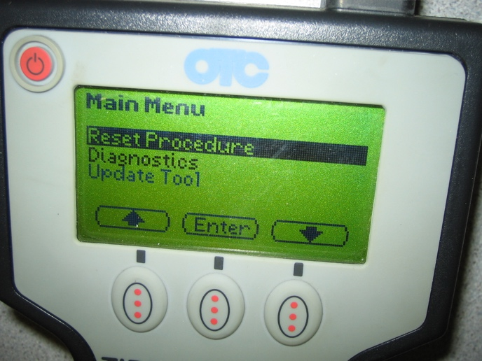

____ Indirect

____ Direct

If direct-type system, what type of

sensor is used?

____ Stem-mounted

____ Banded

____ Unknown

_____ 3. Is recalibrating the sensors needed if the tires are rotated?

____ Yes (If yes, what is the procedure?) ________________________________

____________________________________________________________

____ No

