Traction Control/Vehicle Stability

Meets ASE Task: (A5-G-1) P-1 Identify and inspect electronic brake control system components; determine needed action.

Name _______________________________ Date ___________ Time on Task __________

Make/Model/Year _________________ VIN ________________ Evaluation: 4 3 2 1

_____ 1. Check service information for the specified procedure to follow when inspecting the
electronic brake control system. Describe the procedure. ______________________
_________________________________________________________________
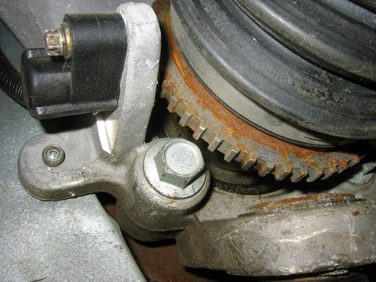
_________________________________________________________________
_____ 2. Describe the location of the following components.
- Wheel speed sensor ________________
________________________________
________________________________
________________________________
________________________________
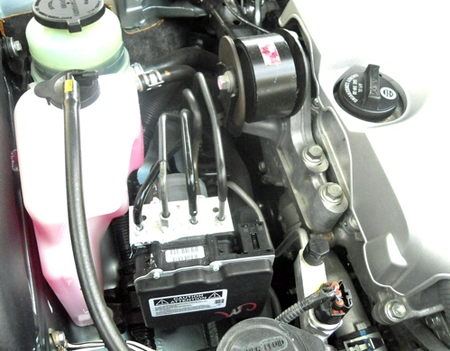

Hydraulic control assembly __________

_________________________________

_________________________________

_________________________________

_________________________________

Other (describe) ____________________________________________________________

____________________________________________________________

____________________________________________________________

_____ 3. Based on the inspection, what is the needed action? ___________________________

__________________________________________________________________

