Electronic Brake (ABS) Component Inspection

Meets ASE Task: (A5-G-1) P-1 Identify and inspect electronic brake control system components; determine needed action.

Name _______________________________ Date ___________ Time on Task __________

Make/Model/Year _________________ VIN ________________ Evaluation: 4 3 2 1

_____ 1. Check service information for the identification of the electronic brake system and the

exact procedure to follow during an inspection.

Type of electronic brake system = ______________________________________

Describe the specified inspection procedure: _____________________________

__________________________________________________________________

_____ 2. Inspect all components of the electronic brake system. (check all that apply)

____ Master cylinder ____ OK ____ NOT OK
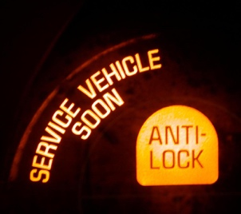

____ Electrohydraulic unit ____ OK ____ NOT OK

____ Accumulator(s) ____ OK ____ NOT OK

____ Electronic control unit ____ OK ____ NOT OK

____ Wheel speed sensors ____ OK ____ NOT OK

____ Other (describe) _______________________________________________

____ 3. What tools or equipment was needed to perform the inspection and/or testing? (check

all that apply)

____ Scan tool ____ DMM ____ Mirror

____ Pressure gauge Other (describe) ____________________________

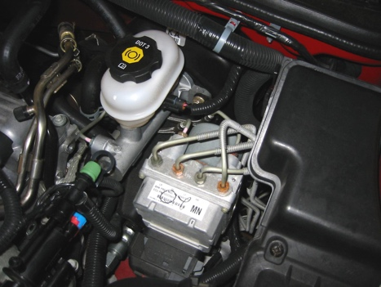
____ 4. Based on the inspection, what is the needed action?

_________________________________________

_________________________________________

