Electronic Brake Control System Components
Meets ASE Task: (A5-G-1) P-1 Identify traction control/vehicle stability control system components.

Name _______________________________ Date ___________ Time on Task __________

Make/Model/Year _________________ VIN ________________ Evaluation: 4 3 2 1

_____ 1. Check service information to determine what components are included in the traction
control/vehicle stability control system (check all that apply).

___ ABS electrohydraulic control unit
___ ABS/traction control computer (controller)
___ Wheel speed sensors
___ Steering wheel position sensor
___ Vehicle speed sensor
___ Lateral force (“G”) sensor
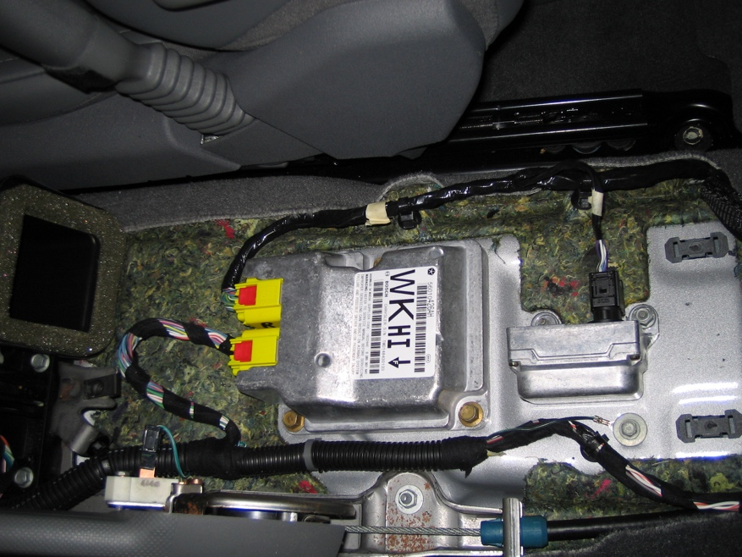

_____ 2. Describe the location of each of the components.

_________________________________________________________________
_________________________________________________________________
_________________________________________________________________
_________________________________________________________________
_________________________________________________________________

