Master Cylinder Pushrod Length

Meets ASE Task: (A5-E-5) P-3 Measure and adjust master cylinder pushrod length.

Name _______________________________ Date ___________ Time on Task __________

Make/Model/Year _________________ VIN ________________ Evaluation: 4 3 2 1

_____ 1. Check service information for the specified procedures and specifications for checking
and adjusting master cylinder pushrod length.

__________________________________________________________________
__________________________________________________________________
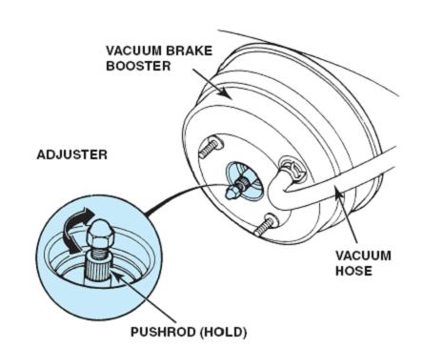

_____ 2. Where is the measurement taken?
__________________________________________________________________

_____ 3. Is a “go-no go” gauge needed? If so, what is the part number? ___________________

_____ 4. Describe the symptoms if the master cylinder pushrod length is not correct.
__________________________________________________________________
__________________________________________________________________

