Hydro-Boost Test
Meets ASE Task: (A5-E-4) P-3 Inspect and test hydro-boost system for leaks and proper
operation.

Name _______________________________ Date ___________ Time on Task __________

Make/Model/Year _________________ VIN ________________ Evaluation: 4 3 2 1

_____ 1. Check the service information for the specified Hydro-Boost testing procedure for the
vehicle being serviced.
_________________________________________________________________

_____ 2. Start the testing of a Hydro-boost power brake assist system by carefully inspecting
the following components:

Power steering fluid level OK _____ NOT OK _____
Power steering pressure hoses for leaks OK _____ NOT OK _____
Power steering pump drive belt OK _____ NOT OK _____
Master cylinder brake fluid level OK _____ NOT OK _____
Visually inspect the Hydro-boost assembly
for evidence of power steering fluid leaks OK _____ NOT OK _____

_____ 3. Check the operation of the base hydraulic brakes by depressing the brake pedal several
times with the engine "off" until the brake pedal feels firm. Continue to apply force to
the brake pedal. The brake pedal should not drop.
OK _____ NOT OK _____(master cylinder or hydraulic system fault is
indicated)

_____ 4. With your foot still applying force to the brake pedal, start the engine. If the
Hydro-boost system is functioning correctly, the brake pedal should drop.
OK _____ NOT OK _____
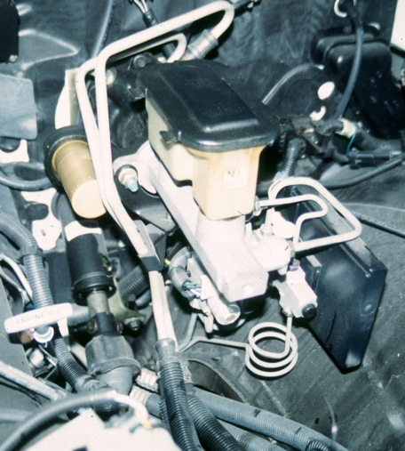
_____ 5. To check the power steering pump for proper operation,
connect a power steering pressure gauge or pressure and
volume gauge between the pump and the Hydro-boost
unit. Start the engine and observe the pressure and
volume gauges.
Pressure at idle = _________
(should be less than 150 psi)
OK _____ NOT OK _____

Volume at idle = __________
(should be at least 2 gallons per minute)
OK _____ NOT OK _____

